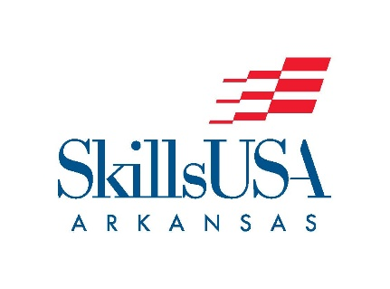

Automotive Parts Specialist 2026

Competitor Must Bring Computer

Purpose
- To evaluate each contestant’s preparation for employment and to recognize outstanding students for excellence and professionalism in the field of automotive aftermarket parts.

Clothing Requirement
- Official SkillsUSA light blue work shirt and navy pants, black or brown leatherwork shoes.

Scope of the Contest
- The contest is divided into five portions.
  - Numeric-Alphabetic order by part number.
  - Identification of common auto parts.
  - Uses industry catalogs to identify part numbers quickly and accurately for specific applications.
  - General knowledge exam with content including, gross profit, inventory management, customer service, evaluation and problem solving.
  - Math exam with content including calculating discounts, inventory turnover, gross margin, and sales tax.

Resume
- To avoid point reduction each contestant is required to submit a resume.

