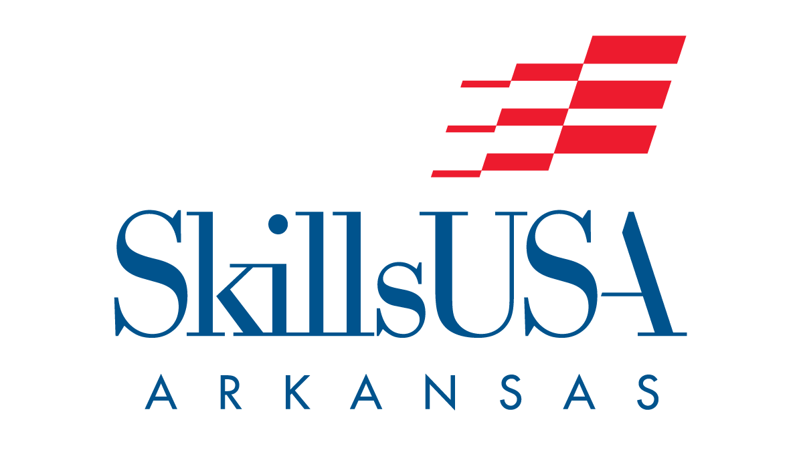
Dear ???????,
SkillsUSA is recognized by the U. S. Department of Education and the U. S. Department of Labor as a successful model of employer-driven youth development training. We have developed over 14.2 million student members into the skilled workforce since 1965.
Our mission is to empower our members to become world-class workers, leaders and responsible citizens. SkillsUSA is a partnership of students, teachers and industry working together to ensure the United States has a skilled workforce. Together we actualize our vision to produce the most highly skilled workforce in the world, providing every member the opportunity for career success.
SkillsUSA Arkansas has two conferences a year. Our Leadership conference in October and Spring conference in April. We bring over 1000 contestants and instructor to Hot Spring Convention Center for our Skilled and Leadership contests.
Learn more about a partnership with us:
- Viewing this Video
- SkillsUSA Arkansas Sponsorships Booth Rental 2023 Sponsorship Document 2023
- SkillsUSA website www.arskillsusa.org
If you would like to meet, please call or email Keith McKnight keith.mcknight@ade.arkansas.gov or 1-501-682-1125 for more information.

