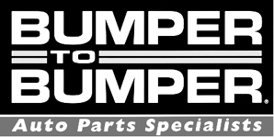
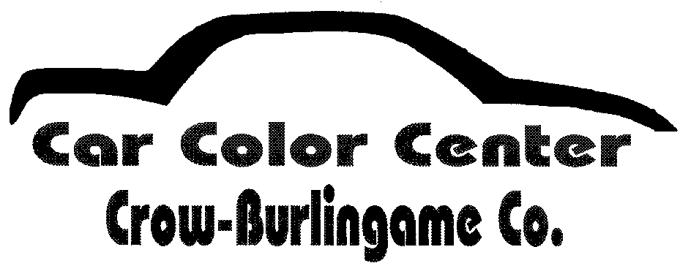
Automotive Collision and Refinishing
Consumables Provided:
StickIt Sanding Paper Various Grits – 6”DA, File Board, Sanding Block.
Body Filler
Spreaders, Mixing Boards, Stir Sticks and Mixing Cups
Welding Panels
Fenders for Repairing and Panels for Painting
3M PPS Cups 2.0 for paint spray gun. These use the 2.0 style gun adapters, not provided.
Sealer / Color Coat / Clear Coat
Latex Gloves
Paper Towels and Tac Cloths
Plastic Repair Products

Items NOT Included:
Personal Protection – Working Gloves, Welding Hood, Safety Glasses, Respirators, Dust Mask
Tools – DA Sander, Backing Pads, Files, Hand Tools (hammer / dollies), High Flo Fittings for Air Tools,
Paint Spray Guns
SKILLS Provided:
Estimating Computers w/Estimating Software and IT Set Up Person
Welders (2) Person to Set Up.
AIR Compressor
Spray Booth

